Chavangkon Kanjanakuldit (Ken) 6681371

https://github.com/Ken19149/Graphics/tree/main/week_3

**Cir-Bres.cpp**

#define GL_SILENCE_DEPRECATION

#include <iostream>

#include <vector>

#include <cmath>

#ifdef __APPLE__

#include <GLUT/glut.h>

#else

#include <GL/glut.h>

#endif

using namespace std;

int screenWidth = 800; // HERE

int screenHeight = 600; // HERE

vector<pair<pair<int, int>, int>> circles; // Store (center, radius)

bool drawingCircle = false;

int circleCenterX, circleCenterY;

void drawDot(int x, int y)

{

glBegin(GL_POINTS);

glVertex2i(x, y);

glEnd();

}

// Bresenham Circle Drawing Algorithm

void drawCircleBresenham(int xc, int yc, int r)

{

int x = 0;

int y = r;

int pk = 3 - 2 * r;

while (x <= y)

{

// Draw all eight symmetric points

drawDot(xc + x, yc + y); // Quadrant1

drawDot(xc + y, yc + x); // ... Quadrant2

drawDot(xc + y, yc - x); // ... Quadrant3

drawDot(xc + x, yc - y); // ... Quadrant4

drawDot(xc - x, yc - y); // ... Quadrant5

drawDot(xc - y, yc - x); // ... Quadrant6

drawDot(xc - y, yc + x); // ... Quadrant7

drawDot(xc - x, yc + y); // ... Quadrant8

x++;

if (pk < 0)

{

// pk ... case #1 <-- HERE

pk = pk + 4*x + 6;

}

else

{

y--;

// pk ... case #2 <-- HERE

pk = pk + 4*(x-y) + 10;

}

}

}

void display()

{

glClear(GL_COLOR_BUFFER_BIT);

glColor3f(1.0, 1.0, 1.0); // <-- HERE

// Draw all circles using Bresenham algorithm

for (const auto &circle : circles)

{

drawCircleBresenham(circle.first.first, circle.first.second, circle.second);

}

glutSwapBuffers();

}

void mouse(int button, int state, int x, int y)

{

y = screenHeight - y;

if (button == GLUT_LEFT_BUTTON && state == GLUT_DOWN)

{

if (!drawingCircle)

{

circleCenterX = x;

circleCenterY = y;

drawingCircle = true;

cout << "Circle center at (" << x << ", " << y << ")" << endl;

}

else

{

int radius = (int)sqrt(pow(x - circleCenterX, 2) + pow(y - circleCenterY, 2));

circles.push_back({{circleCenterX, circleCenterY}, radius});

drawingCircle = false;

cout << "Circle with radius: " << radius << " (Bresenham Algorithm)" << endl;

}

}

glutPostRedisplay();

}

void keyboard(unsigned char key, int x, int y)

{

if (key == ' ')

{

circles.clear();

cout << "Screen cleared" << endl;

}

else if (key == 'q' || key == 'Q')

{

exit(0);

}

glutPostRedisplay();

}

void init()

{

glClearColor(0.0, 0.0, 0.0, 1.0);

glMatrixMode(GL_PROJECTION);

glLoadIdentity();

gluOrtho2D(0, screenWidth, 0, screenHeight);

glPointSize(2.0);

}

int main(int argc, char **argv)

{

glutInit(&argc, argv);

glutInitDisplayMode(GLUT_DOUBLE | GLUT_RGB);

glutInitWindowSize(screenWidth, screenHeight);

glutInitWindowPosition(100, 100); // <-- HERE

glutCreateWindow("Bresenham Circle Algorithm");

init();

glutDisplayFunc(display);

glutMouseFunc(mouse);

glutKeyboardFunc(keyboard);

cout << "=== Bresenham Circle Algorithm ===" << endl;

cout << "Click for center, then click for radius" << endl;

cout << "Space - Clear Screen" << endl;

cout << "Q - Quit" << endl;

glutMainLoop();

return 0;

}

Output:

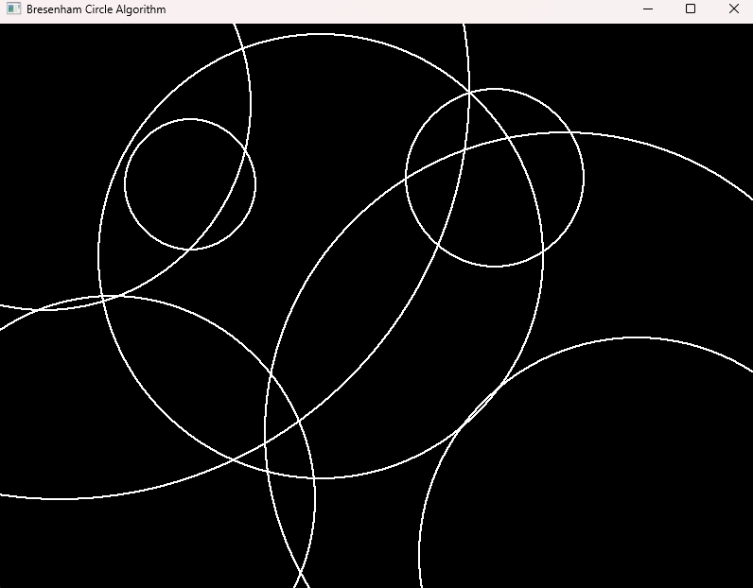

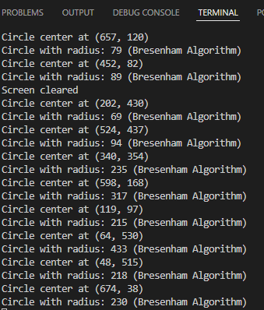

Draw a circle using the mouse click position as the center then use the next click to calculate the radius.

**Cir-MidP.cpp**

#define GL_SILENCE_DEPRECATION

#include <iostream>

#include <vector>

#include <cmath>

#ifdef __APPLE__

#include <GLUT/glut.h>

#else

#include <GL/glut.h>

#endif

using namespace std;

int screenWidth = 800;

int screenHeight = 600;

vector<pair<pair<int, int>, int>> circles; // Store (center, radius)

bool drawingCircle = false;

int circleCenterX, circleCenterY;

void drawDot(int x, int y)

{

glBegin(GL_POINTS); // <-- HERE

glVertex2i(x, y); // <-- HERE

glEnd();

}

void drawCircleMidpoint(int xc, int yc, int r)

{

int x = 0;

int y = r;

int pk = 1 - r;

while (x <= y)

{

// Draw all eight symmetric points // <-- HERE

drawDot(xc + x, yc + y); // Quadrant1

drawDot(xc + y, yc + x); // ... Quadrant2

drawDot(xc + y, yc - x); // ... Quadrant3

drawDot(xc + x, yc - y); // ... Quadrant4

drawDot(xc - x, yc - y); // ... Quadrant5

drawDot(xc - y, yc - x); // ... Quadrant6

drawDot(xc - y, yc + x); // ... Quadrant7

drawDot(xc - x, yc + y); // ... Quadrant8

x++;

if (pk < 0)

{ // <-- HERE

// pk ... case #1

pk = pk + 2*x + 1;

}

else

{

y--;

// pk ... case #2

pk = pk + 2*(x-y) + 1;

}

}

}

void display()

{

glClear(GL_COLOR_BUFFER_BIT);

glColor3f(1.0, 1.0, 1.0); // <-- HERE

// Draw all circles using Midpoint algorithm

for (const auto &circle : circles)

{

drawCircleMidpoint(circle.first.first, circle.first.second, circle.second);

}

glutSwapBuffers();

}

void mouse(int button, int state, int x, int y)

{

y = screenHeight - y;

if (button == GLUT_LEFT_BUTTON && state == GLUT_DOWN)

{

if (!drawingCircle)

{

circleCenterX = x;

circleCenterY = y;

drawingCircle = true;

cout << "Circle center at (" << x << ", " << y << ")" << endl;

}

else

{

int radius = (int)sqrt(pow(x - circleCenterX, 2) + pow(y - circleCenterY, 2));

circles.push_back({{circleCenterX, circleCenterY}, radius});

drawingCircle = false;

cout << "Circle with radius: " << radius << " (Midpoint Algorithm)" << endl;

}

}

glutPostRedisplay();

}

void keyboard(unsigned char key, int x, int y)

{

if (key == ' ')

{

circles.clear();

cout << "Screen cleared" << endl;

}

else if (key == 'q' || key == 'Q')

{

exit(0);

}

glutPostRedisplay();

}

void init()

{

glClearColor(0.0, 0.0, 0.0, 1.0); // <-- HERE

glMatrixMode(GL_PROJECTION);

glLoadIdentity();

gluOrtho2D(0, screenWidth, 0, screenHeight);

glPointSize(2.0);

}

int main(int argc, char **argv)

{

glutInit(&argc, argv);

glutInitDisplayMode(GLUT_DOUBLE | GLUT_RGB);

glutInitWindowSize(screenWidth, screenHeight);

glutInitWindowPosition(100, 100); // <-- HERE

glutCreateWindow("Midpoint Circle Algorithm");

init();

glutDisplayFunc(display);

glutMouseFunc(mouse);

glutKeyboardFunc(keyboard);

cout << "=== Midpoint Circle Algorithm ===" << endl;

cout << "Click for center, then click for radius" << endl;

cout << "Space - Clear Screen" << endl;

cout << "Q - Quit" << endl;

glutMainLoop();

return 0;

}

Output:

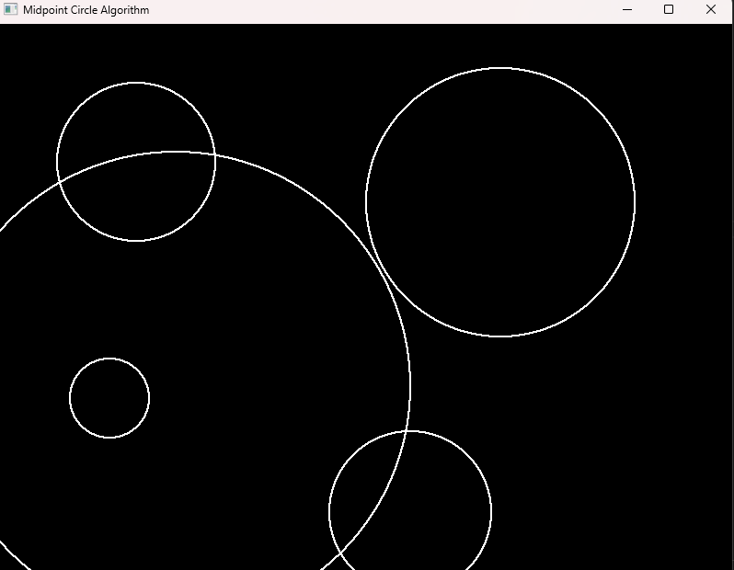

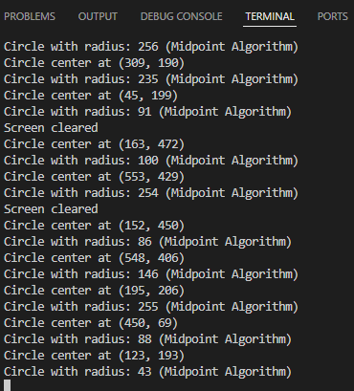

Draw a circle using the mouse click position as the center then use the next click to calculate the radius.

**Lin-Bres.cpp**

#define GL_SILENCE_DEPRECATION

#include <iostream>

#include <vector>

#include <cmath>

#ifdef __APPLE__

#include <GLUT/glut.h>

#else

#include <GL/glut.h>

#endif

using namespace std;

int screenWidth = 800;

int screenHeight = 600;

vector<pair<int, int>> lines; // Store pairs of points for lines

void drawDot(int x, int y)

{

glBegin(GL_POINTS);

glVertex2i(x, y);

glEnd();

}

/* // template

void drawLineBresenham(int x1, int y1, int x2, int y2)

{

int dx = abs(x2 - x1);

int dy = abs(y2 - y1);

// variables, what are they? // <-- HERE

int n = dy > dx ? dy : dx; // it doesn't stop on loop so i use longer end instead

for (int i=0;i<n;i++)

{

drawDot(x1, y1);

if (x1 == x2 && y1 == y2) break;

int pk = 2*dy - dx;

std::cout << x1 << " " << y1 << " " << pk << std::endl;

if (pk < 0)

{

// do something // <-- HERE

pk = pk + 2*dy;

x1++;

}

if (pk >= 0)

{

// do something // <-- HERE

pk = pk + 2*dy - 2*dx;

x1++;

y1++;

}

}

}

*/

// my function

void drawLineBresenham(int x1, int y1, int x2, int y2) {

int dx = abs(x2 - x1);

int dy = abs(y2 - y1);

int sx = (x1 < x2) ? 1 : -1;

int sy = (y1 < y2) ? 1 : -1;

int err = dx - dy;

int n = dy > dx ? dy : dx;

for (int i=0;i<n;i++) {

drawDot(x1, y1);

int e2 = 2*err;

if (e2 > -dy) { err -= dy; x1 += sx; }

if (e2 < dx) { err += dx; y1 += sy; }

// std::cout << x1 << " " << y1 << std::endl;

}

}

void display()

{

glClear(GL_COLOR_BUFFER_BIT);

glColor3f(1.0, 1.0, 1.0); // <-- HERE

// Draw all lines using Bresenham algorithm

for (size_t i = 0; i + 1 < lines.size(); i += 2)

{

drawLineBresenham(lines[i].first, lines[i].second,

lines[i + 1].first, lines[i + 1].second);

}

glutSwapBuffers();

}

void mouse(int button, int state, int x, int y)

{

y = screenHeight - y;

if (button == GLUT_LEFT_BUTTON && state == GLUT_DOWN)

{

lines.push_back({x, y});

cout << "Point at (" << x << ", " << y << ")" << endl;

if (lines.size() % 2 == 0)

{

cout << "Line drawn using Bresenham algorithm" << endl;

}

}

glutPostRedisplay();

}

void keyboard(unsigned char key, int x, int y)

{

if (key == ' ')

{

lines.clear(); // <== ERROR: change from circles.clear() to lines.clear()

cout << "Screen cleared" << endl;

}

else if (key == 'q' || key == 'Q')

{

exit(0);

}

glutPostRedisplay();

}

void init()

{

glClearColor(0.0, 0.0, 0.0, 1.0); // <-- HERE

glMatrixMode(GL_PROJECTION);

glLoadIdentity();

gluOrtho2D(0, screenWidth, 0, screenHeight);

glPointSize(2.0); // <-- HERE

}

int main(int argc, char** argv) {

glutInit(&argc, argv);

glutInitDisplayMode(GLUT_DOUBLE | GLUT_RGB);

glutInitWindowSize(screenWidth, screenHeight);

glutInitWindowPosition(100, 100); // <-- HERE

glutCreateWindow("Midpoint Circle Algorithm");

init();

glutDisplayFunc(display);

glutMouseFunc(mouse);

glutKeyboardFunc(keyboard);

cout << "=== Bresenham Line Algorithm ===" << endl;

cout << "Click two points to draw a line" << endl;

cout << "Space - Clear Screen" << endl;

cout << "Q - Quit" << endl;

glutMainLoop();

return 0;

}

Output:

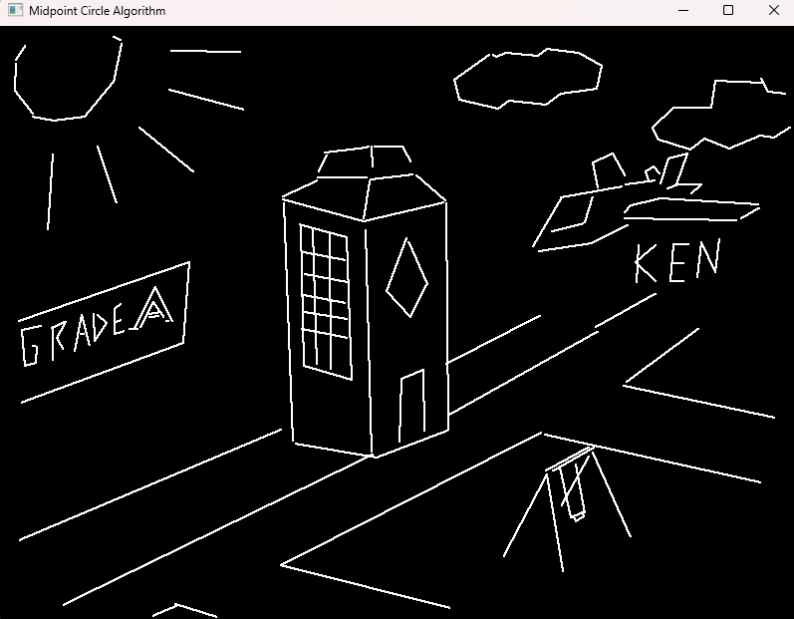

Draw line using bresenham algorithm.

**Rec-Bres.cpp**

#define GL_SILENCE_DEPRECATION

#include <iostream>

#include <vector>

#include <cmath>

#ifdef __APPLE__

#include <GLUT/glut.h>

#else

#include <GL/glut.h>

#endif

using namespace std;

int screenWidth = 800;

int screenHeight = 600;

vector<pair<int, int>> rectangles; // Store pairs of points for rectangles

bool drawingRectangle = false;

int rectStartX, rectStartY;

void drawDot(int x, int y)

{

glBegin(GL_POINTS); // <-- HERE

glVertex2i(x, y); // <-- HERE

glEnd();

}

void drawLineBresenham(int x1, int y1, int x2, int y2)

{

int dx = abs(x2 - x1);

int dy = abs(y2 - y1);

int sx = (x1 < x2) ? 1 : -1;

int sy = (y1 < y2) ? 1 : -1;

int err = dx - dy;

int n = dy > dx ? dy : dx;

for (int i = 0; i < n; i++)

{

drawDot(x1, y1);

int e2 = 2 * err;

if (e2 > -dy)

{

err -= dy;

x1 += sx;

}

if (e2 < dx)

{

err += dx;

y1 += sy;

}

// std::cout << x1 << " " << y1 << std::endl;

}

}

void drawRectangle(int x1, int y1, int x2, int y2)

{

// Draw all four sides using Bresenham line algorithm

drawLineBresenham(x1, y1, x2, y1); // Top

drawLineBresenham(x2, y1, x2, y2); // Right // <-- HERE

drawLineBresenham(x2, y2, x1, y2); // Bottom // <-- HERE

drawLineBresenham(x1, y2, x1, y1); // Left

cout << "Rectangle drawn using line algorithm" << endl;

}

void display()

{

glClear(GL_COLOR_BUFFER_BIT);

glColor3f(1.0, 1.0, 1.0); // <-- HERE

/*

// Draw all rectangles

for (const auto &rect : rectangles)

{

// drawRectangle(rect.first.first, rect.first.second, rect.second.first, rect.second.second);

}

*/

// rewrite the loop

for (size_t i = 0; i + 1 < rectangles.size(); i += 2)

{

drawRectangle(rectangles[i].first, rectangles[i].second,

rectangles[i + 1].first, rectangles[i + 1].second);

}

glutSwapBuffers();

}

void mouse(int button, int state, int x, int y)

{

y = screenHeight - y;

if (button == GLUT_LEFT_BUTTON && state == GLUT_DOWN)

{

/*

if (!drawingRectangle)

{

rectStartX = x;

rectStartY = y;

drawingRectangle = true;

cout << "Rectangle start at (" << x << ", " << y << ")" << endl;

}

else

{

// rectangles.push_back({{rectStartX, rectStartY}, {x, y}});

rectangles.push_back({x, y});

drawingRectangle = false;

cout << "Rectangle completed!" << endl;

}

*/

// the above template doesn't work so used template from the previous bresenham instead :D

rectangles.push_back({x, y});

cout << "Rectangle start at (" << x << ", " << y << ")" << endl;

if (rectangles.size() % 2 == 0)

{

cout << "Rectangle completed!" << endl;

}

}

glutPostRedisplay();

}

void keyboard(unsigned char key, int x, int y)

{

if (key == ' ')

{

rectangles.clear();

cout << "Screen cleared" << endl;

}

else if (key == 'q' || key == 'Q')

{

exit(0);

}

glutPostRedisplay();

}

void init()

{

glClearColor(0.0, 0.0, 0.0, 1.0);

glMatrixMode(GL_PROJECTION);

glLoadIdentity();

gluOrtho2D(0, screenWidth, 0, screenHeight);

glPointSize(2.0);

}

int main(int argc, char** argv) {

glutInit(&argc, argv);

glutInitDisplayMode(GLUT_DOUBLE | GLUT_RGB);

glutInitWindowSize(screenWidth, screenHeight);

glutInitWindowPosition(100, 100);

glutCreateWindow("Rectangle Drawing using Line Algorithm");

init();

glutDisplayFunc(display);

glutMouseFunc(mouse);

glutKeyboardFunc(keyboard);

cout << "=== Rectangle Drawing ===" << endl;

cout << "Click two opposite corners to draw rectangle" << endl;

cout << "Using Bresenham line algorithm for all sides" << endl;

cout << "Space - Clear Screen" << endl;

cout << "Q - Quit" << endl;

glutMainLoop(); // <-- HERE

return 0;

}

Output:

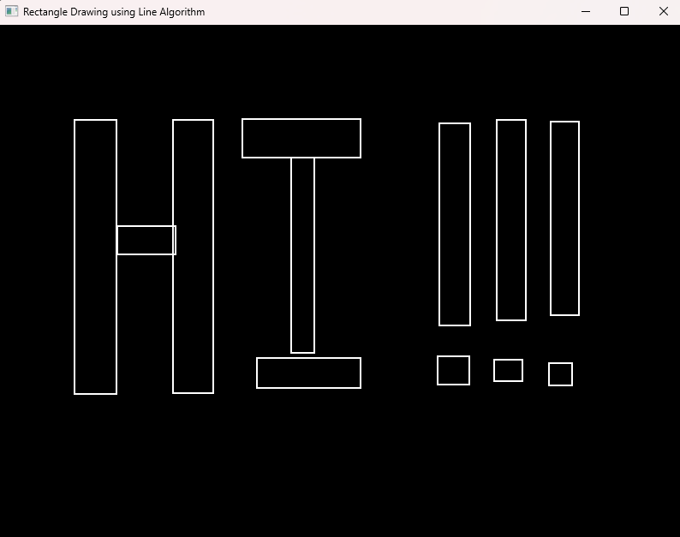

Using 4 lines to draw rectangles and use mouse event to click and draw